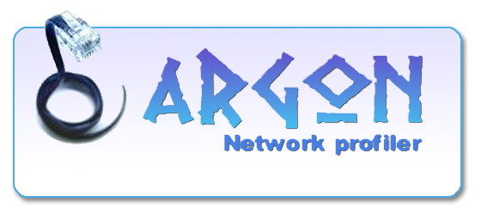

User manual

Version 1.3.1

By
Francesco Benincasa

Index

Introduction
Argon Network Switcher is a network profile manager. It’s very usefully when you connect your pc to different network.

System requirements

User interface
General
Console window
Network adapters window
Adapter window
Profiles window
Profile window

How to
Create a profile
Select network card
Ip config
Proxy config

